this file is much larger and triggers difat sectors

heres a bunch of images to pad out the file size past 6.8 mb:

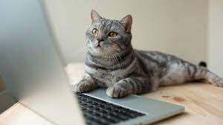

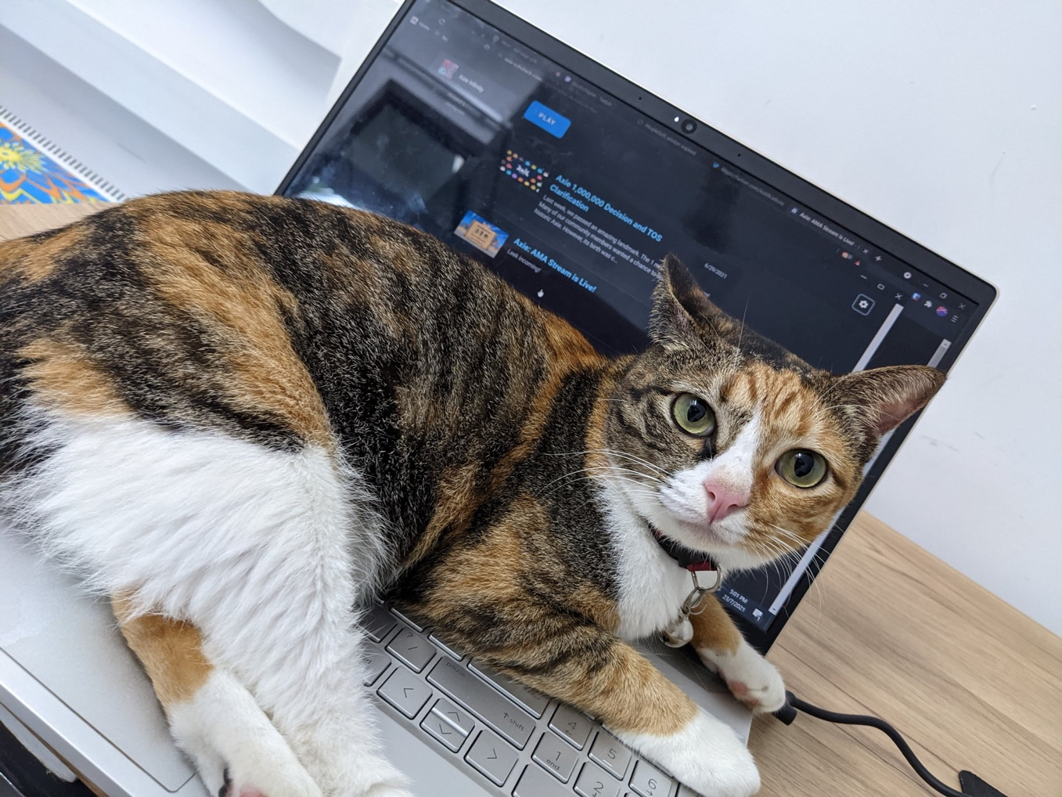

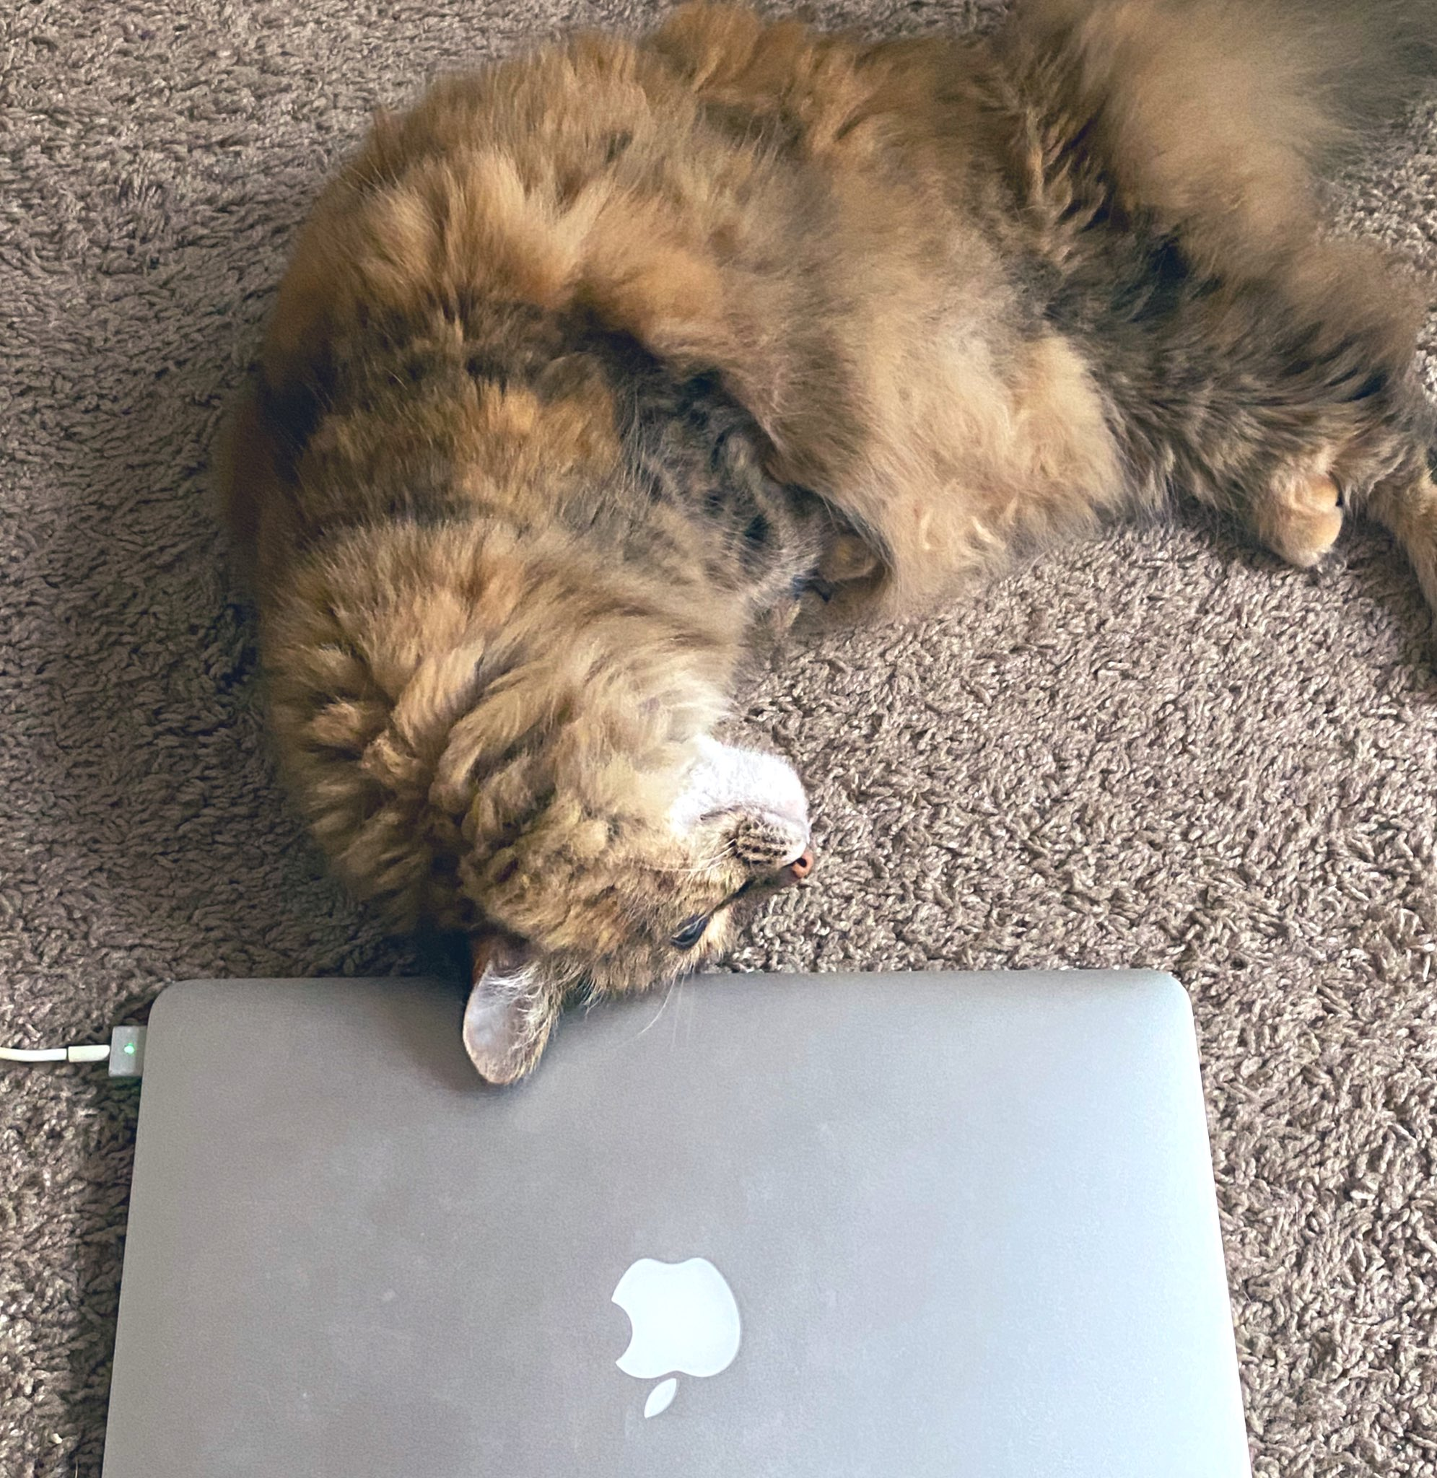

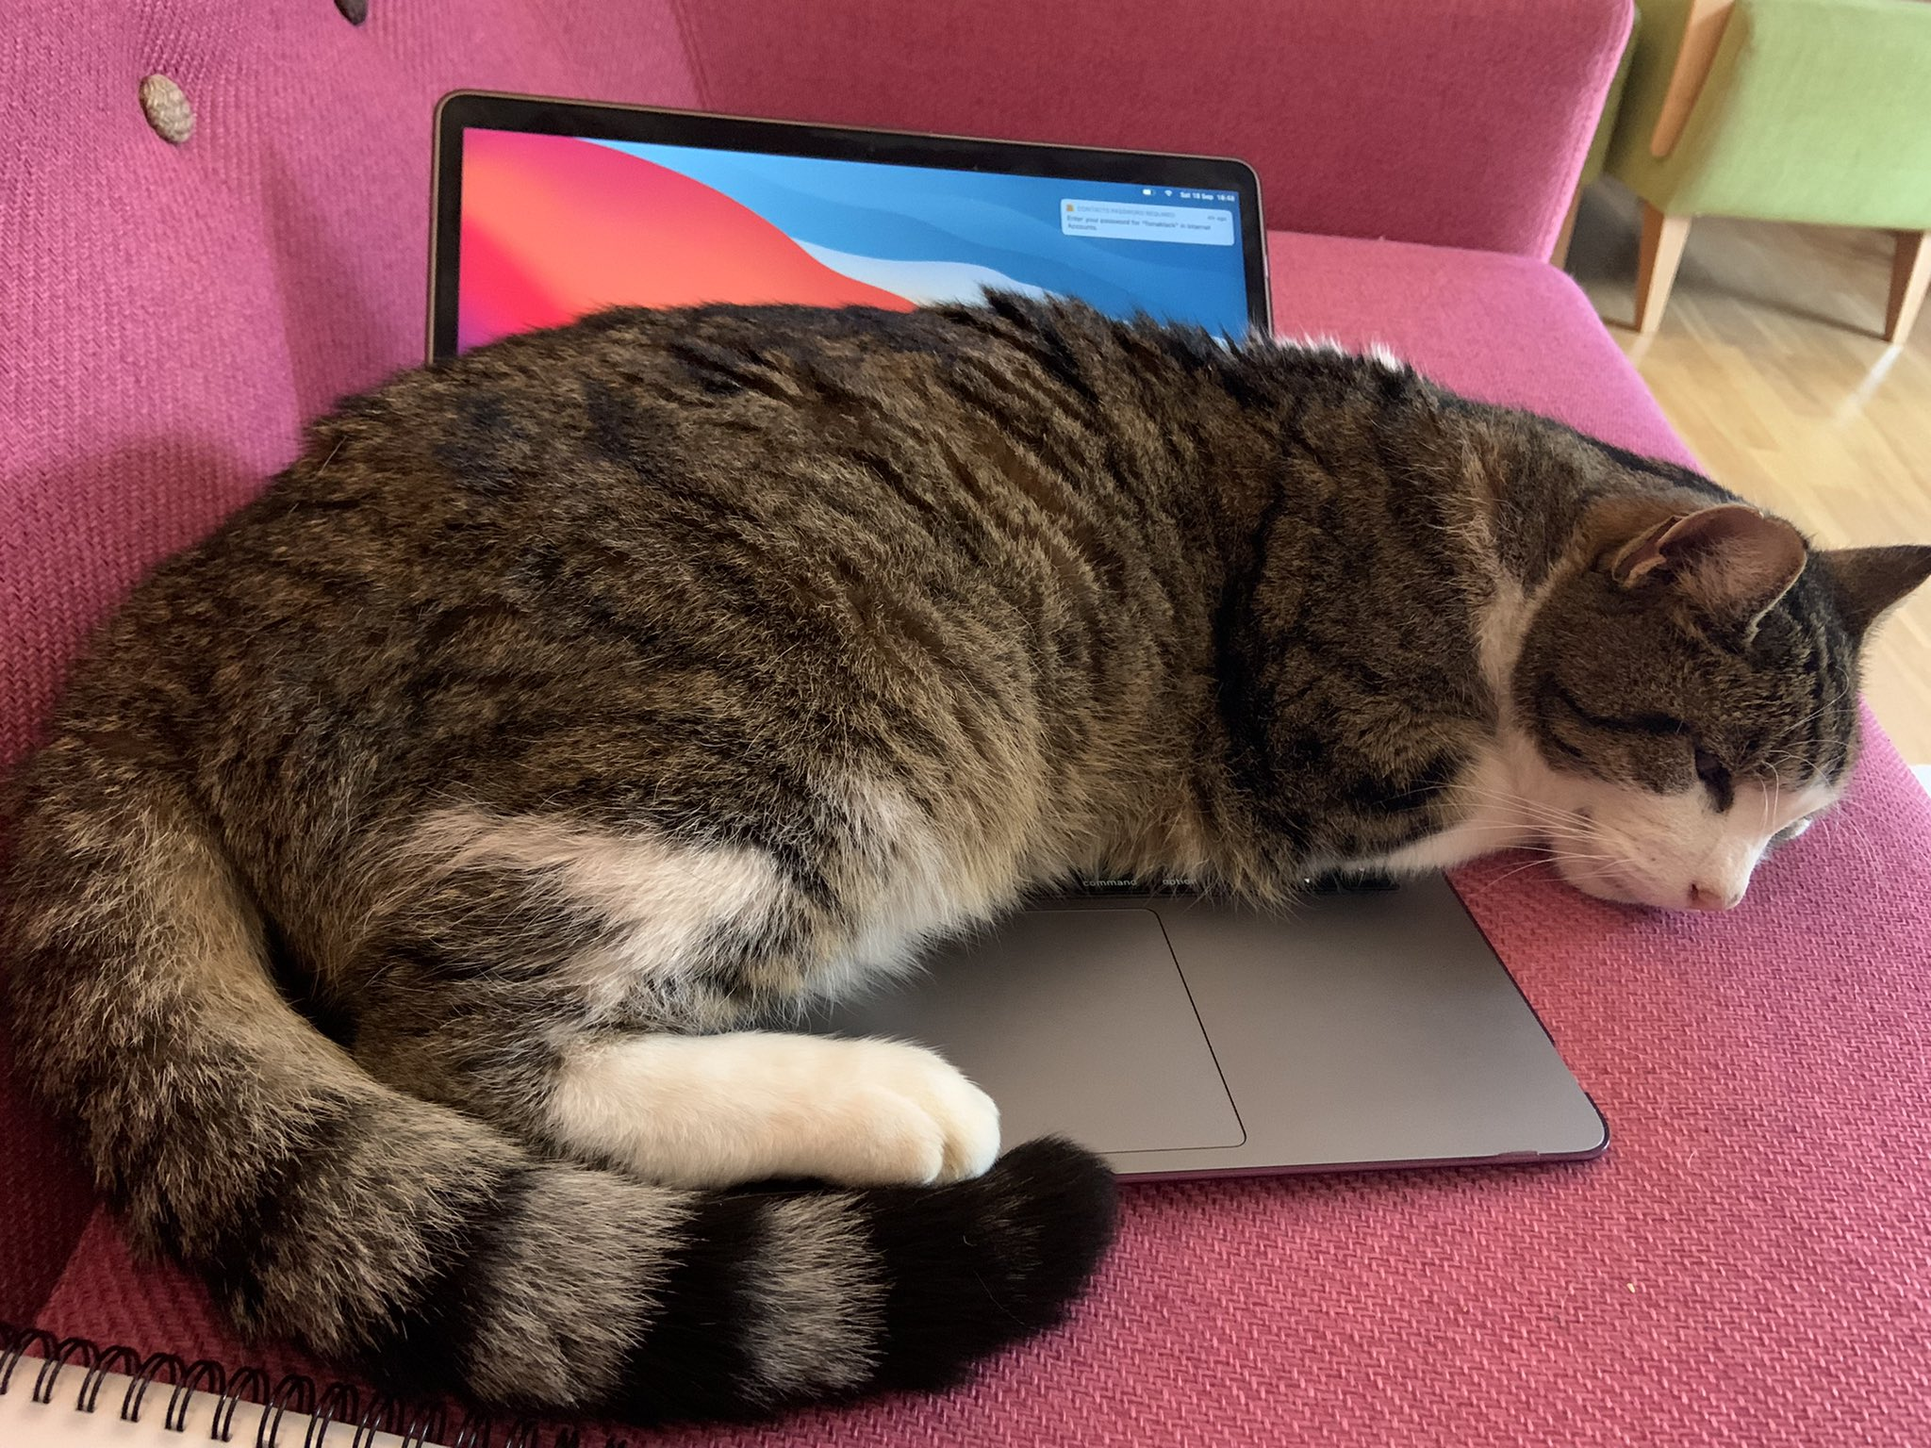

and thats the end of the file